**DATABASE FOR THE SELECTION OF WEAPONS**

v. 1.0

**done by Yurii Bondar**

**(group B18, Vinnytsia IT-Academy)**

**Task obtained: 02.02.2019**

**Pre-defence: 16.02.2019, Teacher1 __________**

**Defence: 23.02.2019, Teacher2 __________**

**CONTENTS**

**1. System requirements**

**2. About program “Database for selection of weapons”**

**3. User guide**

**4. Programmer instruction**

**5. About the author**

**1. System requirements**

**Operating system:** DOS or Windows.

**Hardware requirements:** user (programmer) requires

- processor: Pentium Processor;

- RAM: 640 Kb (min);

- Hard Disc: 1 Gb (min).

**2. About program “Database for selection of weapons”**

The program allows you to carry out the selection of weapons, ammunition and sights according to your needs. The information is contained in the database tables.

In this program sqlite3 database is used. SQLite is a C-language library that implements a small, fast, self-contained, high-reliability, full-featured, SQL database engine. SQLite is the most used database engine in the world.

The program interface includes the main menu and the basket menu as shown in the pictures below:

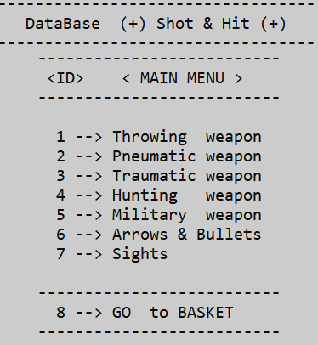 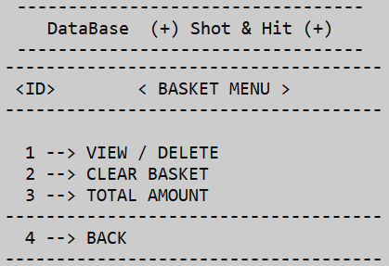

*Main menu Basket menu*

**3. User guide**

**a.** Find and run file DBW.exe in the folder DataBaseWeapon.

**b.** Read information about program’s name and author and press any key.

**c.** Read the description of the application that is shown below.

**d.** Read the list provided and choose what you need.

**e.** Click on buttons “Main menu”, depending on what you need to do:

* buttons '1' - '7' will redirect you to the list of necessary elements for selection;
* button '8' allows you to enter advanced menu of the basket.

**f.** Click on buttons “Basket menu”, depending on what you need to do:

* button '1' opens a list of the items you have selected, remove a specific item from the basket by ID;
* button '2' completely clears the basket by deleting all items;
* button '3' shows the total cost of the selected items;
* button '4' calls the buttons to go to the main menu or exit the program.

**4. Programmer instruction**

The project was written on C.

Advantages of C:

**Portability:** ‘C’ is one of the most used and portable to different platforms, almost any type of computer and operating system.

**Brevity:** code written in ‘C’ is very short in comparison with other languages.

**Modular programming:** applications written on ‘C’ can be made up of several source code files which are compiled separately and then linked together. This characteristic allows to link ‘C’ code with the one written in other languages.

**Speed:** The resulting code from a ‘C’ compilation is very efficient due to the reduced size of the language itself.

The project is a block that contains all the necessary files with implemented algorithms and functions.

Find and open files: main.c, tables.c, crud.c, tables.h, crud.h, sqlite3.c, sqlite3.h in folder DataBaseWeapon. For edition, debugging and compiling program code you may use C/C++ compilers such as QT-creator, MS Visual Studio, C++ Builder, Borland C++, Dev C++ and similar.

Main global variables:

sqlite3 *db – pointer to the database MySQL using the library “sqlite3.h”;

int rc – flag to verify the successful finding or opening of the database;

char *zErrMsg – will be returned to capture any error raised by the routine;

char* sql – a pointer that indicates the result of a command to the database;

char sql1[50] – an array that takes the value ‘ID’ entered from the keyboard;

char table [7][255] – array to be able to call the table by index;

int index – a variable for the index which you can select a table;

int ID – variable to enter ‘ID’ from the keyboard.

Main functions:

int THROWING() – provides access to the table “Throwing_weapon” for further operations;

int PNEUMATIC() – provides access to the table “Pneumatic_weapon” for further operations;

int TRAUMATIC() – provides access to the table “Traumatic_weapon” for further operations;

int HUNTING() – provides access to the table “Hunting_weapon” for further operations;

int MILITARY() – provides access to the table “Military_weapon” for further operations;

int AMMUNITION() – provides access to the table “Ammunition” for further operations;

int SIGHTS() – provides access to the table “Sights” for further operations;

int BASKET() – provides access to the table “Basket” for further operations;

void TITLE() – shows the name of the program;

void MAIN_MENU() – shows main menu items;

void BASKET_MENU() – shows basket menu items;

int CALLBACK() – reads data from database tables;

int SUMM_BASKET() – calculates the total cost of the selected items in basket;

int INSERT() – add the desired item from the desired table to the basket by ID;

int DELETE() – removing the desired item from the basket bin by ID;

int MAIN_OPERATION() – implementation of actions of the main menu, the basket menu and exit the program;

void REPEAT() – closing the program only by pressing the corresponding key.

**5. About author**

This project was done by Yurii Bondar – Vinnitsya IT-Academy student (group B18, March 2019).